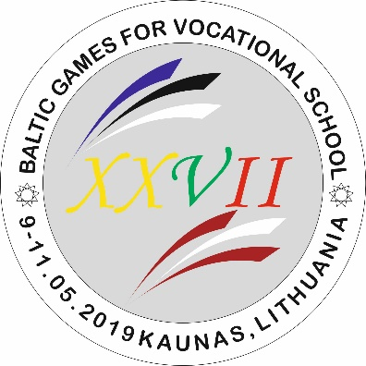
XXVII BALTIC GAMES FOR VOCATIONAL SCHOOLS PROGRAM

THURSDAY, 2019 05 09

16.00 – 18.00 Arrival, registration, accomodation of participants.
- Estonian delegation – Hotel "Via Baltica " Verslo g. 17 , Domeikavos sen., Kumpių k., Kauno raj. LT-54311
- Latvian delegation – Hotel "Sandija" , Jonavos g. 45 , Kaunas LT-44131
19.00 Educational program for the team leaders. Departure from - Hotel

FRIDAY, 2019 05 10
- 09.00 THE OPENING CEREMONY

Basketball – Kaunas Basketball School, Pašilės g. 41, Kaunas
- 10.00 Lietuva – Latvija boys
- 11.30 Lietuva – Latvija girls
- 13.00 Lietuva – Estija boys
- 14.30 Lietuva– Estija girls

Volleyball – Kaunas Basketball School, Pašilės g. 41, Kaunas
- 10.00 Latvija – Estija girls
- 11.30 Estija – Latvija boys
- 13.00 Lietuva – Latvija girls
- 14.30 Lietuva – Latvija boys

Table tennis – – Kaunas Basketball School, Pašilės g. 41, Kaunas
- 10.00 Table tennis for students and employees.
- ≈14.00 Table tennis awarding ceremony.

Basketball 3x3 – Kaunas Basketball School, Pašilės g. 41, Kaunas
- 10.00 Lietuva – Estija girls
- 10.45 Lietuva – Estija boys
- 11.30 Lietuva – Latvija girls
- 12.15 Lietuva – Latvija boys
- 13.00 Latvija – Estija girls
- 13.45 Latvija – Estija boys

School heads competition – Kaunas technical vocational education centre, V. Krėvės pr. 114, Kaunas
- 11.00 School heads basketball free throws
- 12.00 School heads darts
- 13.00 School heads shooting/billiards
- 21.00 School heads awarding ceremony Hotel "Via Baltica " Verslo g. 17 , Domeikavos sen., Kumpių k., Kauno raj. LT-54311

SATURDAY, 2019 05 11

Basketball – Kaunas Basketball School, Pašilės g. 41, Kaunas
- 10.00 Estija – Latvija girls
- 11.30 Latvija – Estija boys

Volleyball – Kaunas Basketball School, Pašilės g. 41, Kaunas
- 10.00 Lietuva – Estija girls
- 11.30 Lietuva – Estija boys
- 13.00 AWARDING & CLOSING CEREMONY

MEAL:

THURSDAY, 2019 05 09
Dinner: 18.30 – 20.30 Hotel "Via Baltica " Verslo g. 17 , Domeikavos sen., Kumpių k., Kauno raj. LT-54311

FRIDAY, 2019 05 10
Breakfast: 6.30 – 8.00 Hotel "Via Baltica " Verslo g. 17 , Domeikavos sen., Kumpių k., Kauno raj. LT-54311
Lunch: 12.00 – 15.00 Kaunas Basketball School, Pašilės g. 41, Kaunas
Dinner studens: 19.00 – 21.00 party time 20.00 – 24.00 Hotel "Via Baltica " Verslo g. 17 , Domeikavos sen., Kumpių k., Kauno raj. LT-54311
Dinner leaders: 19.00 - ..... ? 21.00 School heads awarding ceremony. Hotel "Via Baltica " Verslo g. 17 , Domeikavos sen., Kumpių k., Kauno raj. LT-54311

SATURDAY, 2019 05 11
Breakfast: 7.00 – 9.30 Hotel "Via Baltica " Verslo g. 17 , Domeikavos sen., Kumpių k., Kauno raj. LT-54311
Lunch: 11.00 – 13.00 Kaunas Basketball School, Pašilės g. 41, Kaunas

